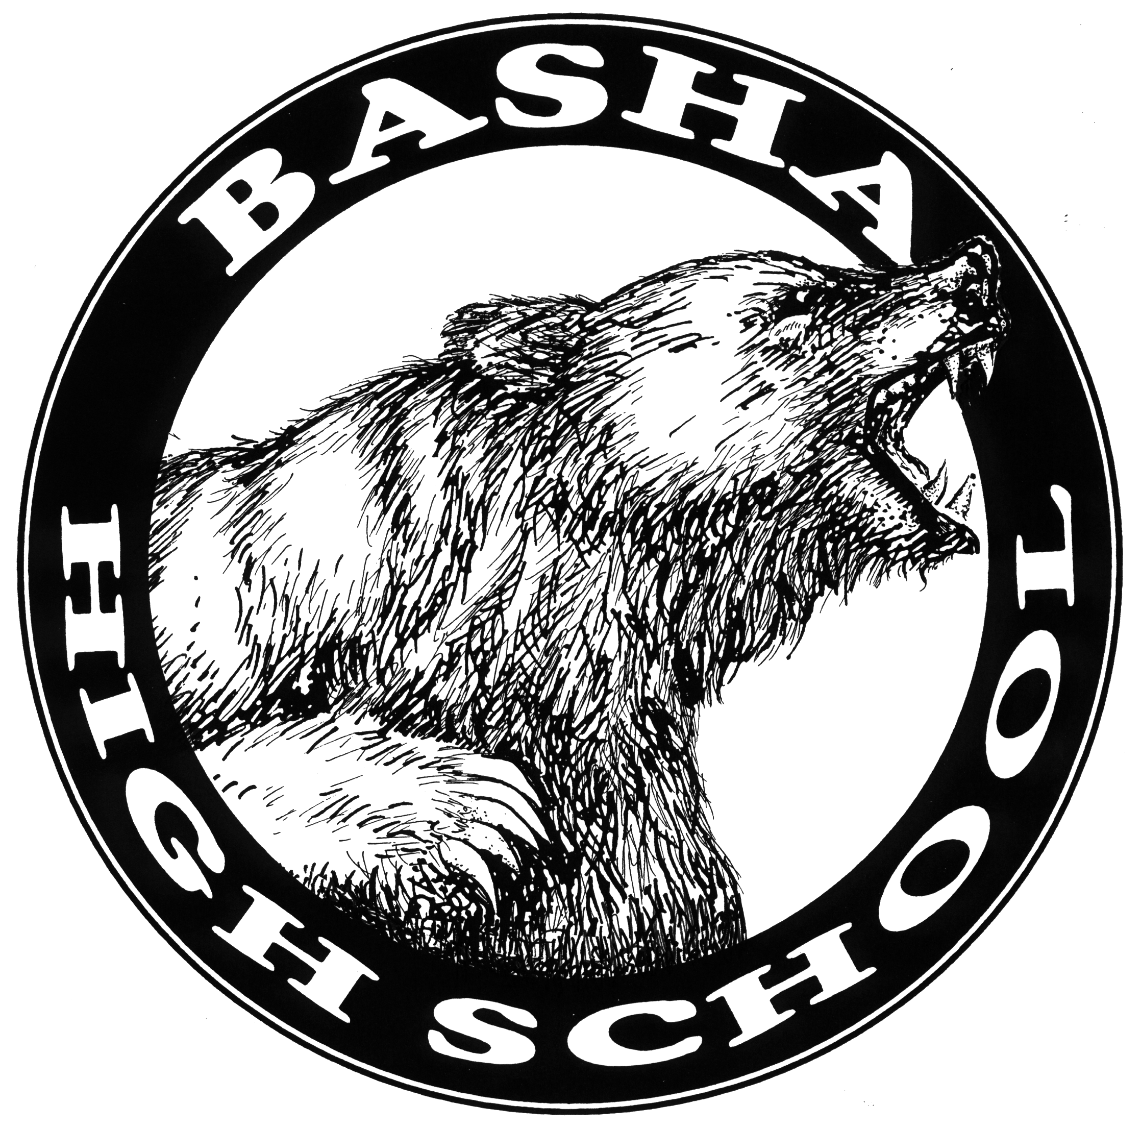
AP Biology
Course Statement Acknowledgement
2020-2021

I acknowledge that I have read over the course statement for AP Biology. I understand the student’s role and responsibilities associated with the course. I understand that if I have any questions or concerns regarding the course grade, content, or requirements, I can contact the instructor.

_________________________________ _____________________________
Parent/Guardian Signature Print Name

_________________________________ _____________________________
Student Signature Print Name

